Spring micro service

**Micro Service:** Small service.

Product

Login

Order

Payment

Manager

Etc

Product module Customer Module Login module

Feedback module payment module

Once we merge the code of all developer we need to re-build the project and deploy we need to create jar or war file.

Micro service : in micro service rather than developing whole application we develop only small part of the application. Those application develop using same language or different language using same database or different database. We deploy those small module independently in separate jar or war file.

Login module -🡪using spring boot with database is my sql and deploy on port number 8080

Customer module -🡪 using spring boot with database is my sql and deploy on port umber 8181

Payment module -🡪 using python with Django framework with database as mongo db deploy on port number 8282

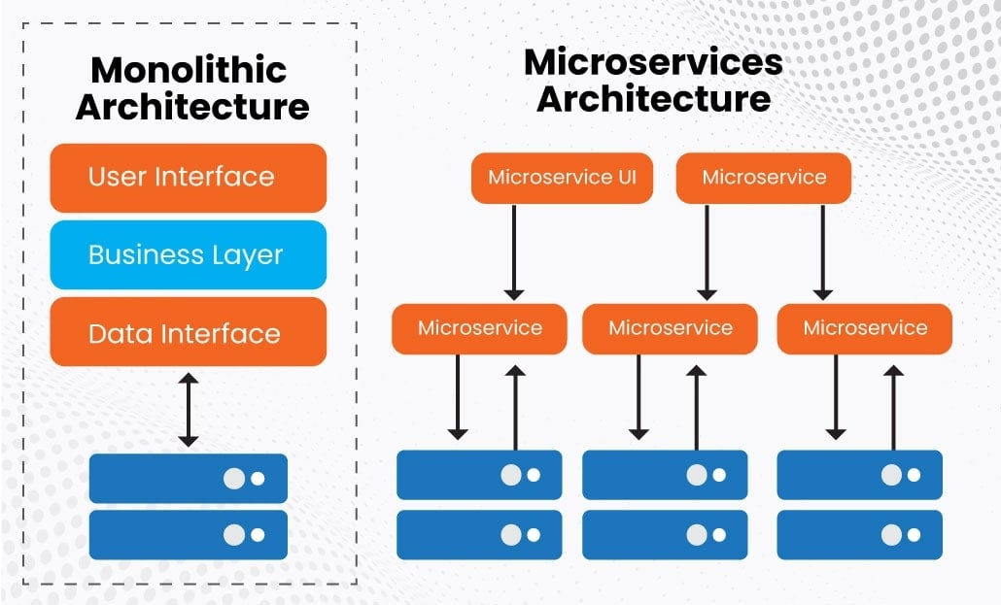

Spring boot provided new module is

**Spring cloud**

Spring provided one the open source server ie Eureka Server. it is a type of an open source server which help deploy more than one micro service project creating using spring boot as well as other technologies.

Role of the Eureka Server is maintain life the each micro service project.

Eureka Server by default run on port number 8761

1. First micro service 8181
2. Second micro service 8282
3. Third micro service 8383

**1st Project Eureka Server**

Starter 🡪Web Starter

Starter -🡪Eureka Server

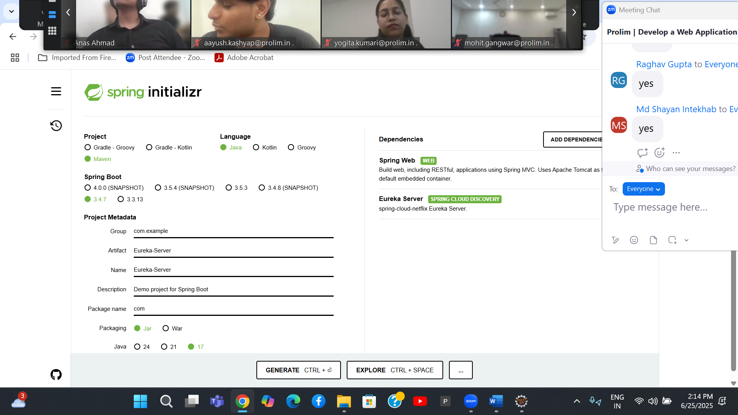

2nd project : creating first micro service project to create simple rest api

8080

Starter -🡪Web Starter

Starter -🡪Eureka Discovery client

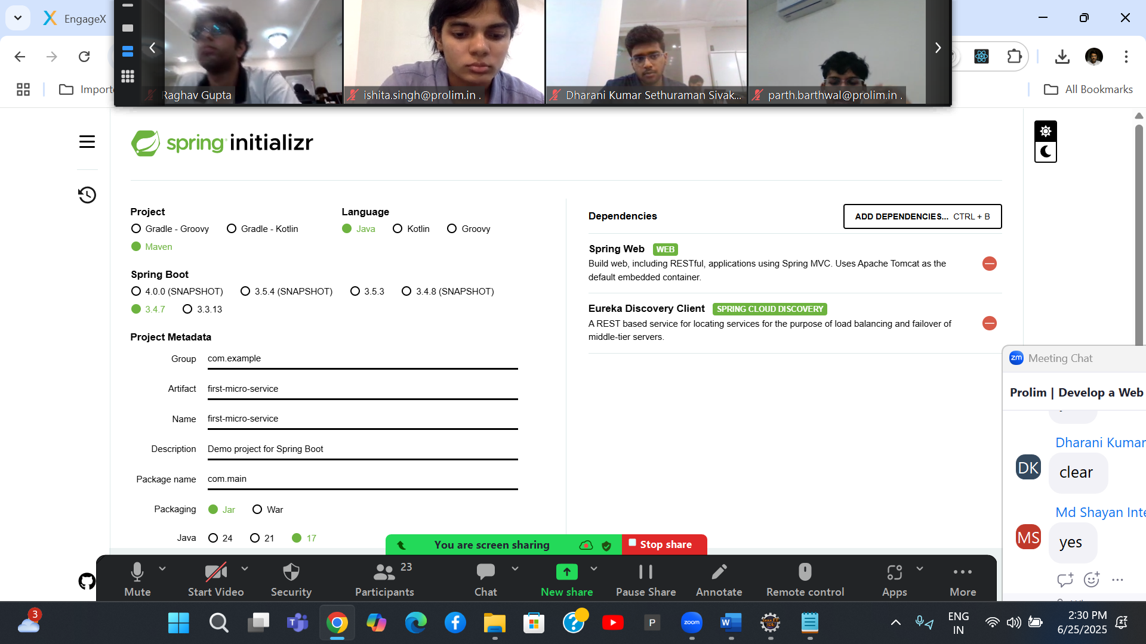

Eureka Server -🡪 Running one machine -🡪 198.162.10.113

First micro service -🡪 Dev1 -----🡪

Second micro service -🡪 Dev2 -----🡪

Third micro service -🡪 Dev2 -----🡪

4th project : Account micro service -🡪 port number 8282 (mysql database)

Starter -🡪Web starter

Starter 🡪 JPA starter

Dependency 🡪 mysql connector

Starter 🡪 Devtools

Starter -🡪 Eureka discovery starter

Post mapping -🡪 create the account (accno, name,emailid(unique), amount) etc

Find balance using accno number

Find account number using emailid

5th project -🡪 Gpay micro service -🡪 8383 ( mysql or h2 database)

Starter -🡪Web starter

Starter 🡪 JPA starter

Dependency 🡪 mysql connector

Starter 🡪 Devtools

Starter -🡪 Eureka discovery starter

While creating gpay account ( we need gpayid (auto increment), emailid and accnuber).

Post mapping 🡪 we passing inly emailid this emailid pass to account micro service to get the account number, if account present then we create gpay account else we display error message gpay account not register with your bank account.

